**Ajah-Sangotedo-Eleko**

## Introduction

A drive test was conducted in Lagos on Wednesday, July 24, 2024, to evaluate the Quality of Service (QoS) provided by four major mobile operators in Nigeria: Airtel, MTN, GLO, and 9Mobile. The assessment spanned the Ajah-Sangotedo-Eleko corridor, a rapidly developing area characterized by a mix of residential estates, commercial hubs, and ongoing infrastructural development. The test was carried out in the morning, starting at 9:26 AM and concluding at 10:48 AM, covering a total duration of 1.3725 hours.

Key Performance Indicators (KPIs) examined during the analysis included Call Setup Success Rate (CSSR), Call Success Rate (CSR), Drop Call Rate (DCR), and Handover Success Rate (HOSR). Additionally, critical parameters such as Received Signal Code Power (RSCP), Received Power (Rx Power), and Signal-to-Noise Ratio (Ec/Io) were monitored to provide a comprehensive understanding of network performance along the route.

## 1.1 Drive Test Route

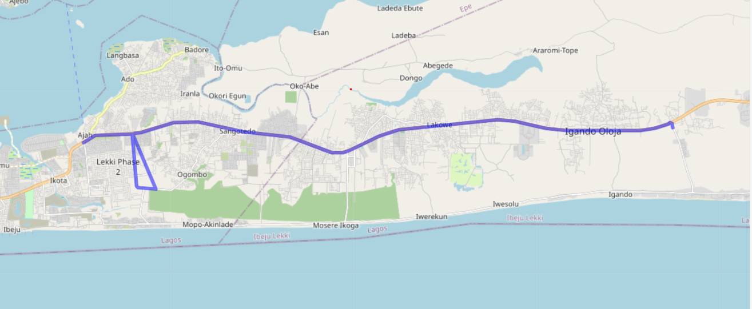

Environmental conditions and geographical features were considered during the analysis to account for potential impacts on network quality. The area’s latitude and longitude data indicated a mix of urban and semi-urban landscapes, with potential signal obstructions from high-rise buildings, vegetation, and construction activities. These factors, combined with the region’s high population density and heavy vehicular traffic, are likely to influence signal propagation and network stability.

This report highlights the QoS performance of the four operators across the Ajah-Sangotedo-Eleko route, offering insights into network strengths and areas requiring improvement. The findings aim to support enhanced decision-making for network optimization and service delivery in the region.

## 1.2 KPI

|  |  |  |  |  |
| --- | --- | --- | --- | --- |
| **Operator** | **CSSR** | **CSR** | **DCR** | **HOSR** |
| **Airtel** | 100 | 100 | 9.090909 | 100 |
| **MTN** | 100 | 100 | 6.060606 | 100 |
| **GLO** | 94.28571 | 94.28571 | 8.571429 | 100 |
| **9MOBILE** | 82.35294 | 82.35294 | 64.70588 | 100 |

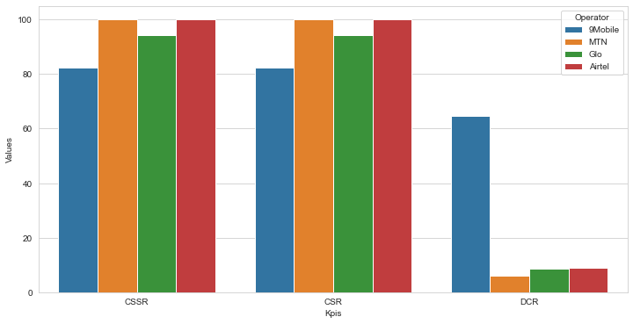

# 2. Mobile Operators

## 2.1 MTN

The MTN network exhibits a generally good performance, with 100% success rates for CSSR, CSR, and HOSR, indicating reliable service with minimal dropped calls. A DCR of 6.06% suggests some call drops occurred. Call establishment was generally successful, with only 2 out of 35 attempted calls blocked. Ecio values indicate generally good signal quality for voice calls with an average of -12.176. Rx Power demonstrates excellent performance with a significant majority of measurements categorized as "Excellent" or "Very Good" and an average of -53.37, indicating strong signal reception. RSCP values, while generally good, show some areas of concern. The average RSCP of -65.996 with a standard deviation of 8.893 suggests potential signal strength variations. A significant portion of measurements fell into the "Fair" category, indicating potential challenges in signal reception and potentially impacting data speeds and overall user experience in certain areas. In summary, while the MTN network exhibits strong call quality and good signal strength in some aspects, the lower RSCP values and the observed DCR indicate potential areas for improvement in overall signal strength and call reliability. Further investigation is recommended to pinpoint the specific locations with weak RSCP and identify potential solutions to enhance the overall user experience.

|  |  |  |
| --- | --- | --- |
| **S/N** | **Parameters** | **Count** |
| 1 | Call Setup | 33 |
| 2 | Call initiation | 35 |
| 3 | Call Established | 33 |
| 4 | Call Dropped | Nil |
| 5 | Call Blocked | 2 |
| 6 | Handover | Nil |
| 7 | Handover Failure | Nil |
| 8 | SHO Procedure Complete | 573 |
| 9 | RRC Call Establishment | 33 |
| 10 | Call Attempt | 33 |

KPIS

|  |  |  |
| --- | --- | --- |
| **s/N** | **Key Parameter Indicators** | **Percentage** |
| 1 | CSSR | 100 |
| 2 | DCR | 6.06 |
| 3 | CSR | 100 |
| 4 | HOSR | 100 |

### 2.11 Ec/Io

Map Plot

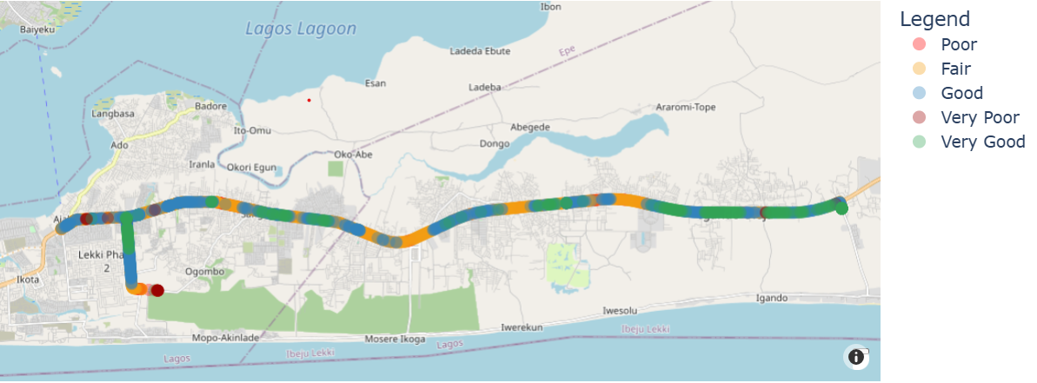

That table and the counts

|  |  |  |  |
| --- | --- | --- | --- |
| **Colors** | **Range of Values** | **Categories** | **Count** |
|  | 0 to -8 | Very Good | 313 |
|  | -9 to -12 | Good | 776 |
|  | -13 to -16 | Fair | 912 |
|  | -17 to -20 | Poor | 105 |
|  | -21 and above | Very Poor | 20 |

Count plot

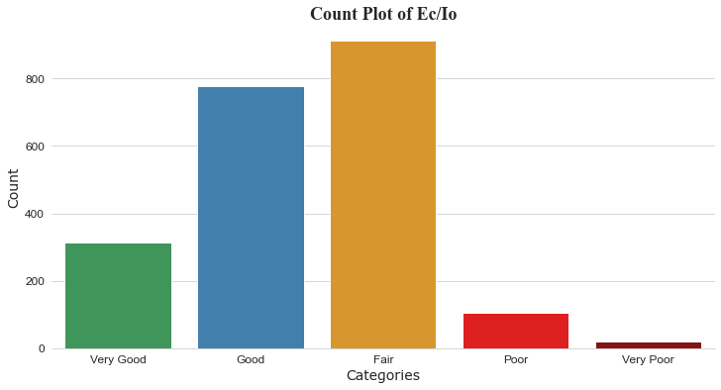

Distribution plot

1. Mean: -12.176
2. Standard Deviation: 3.2107

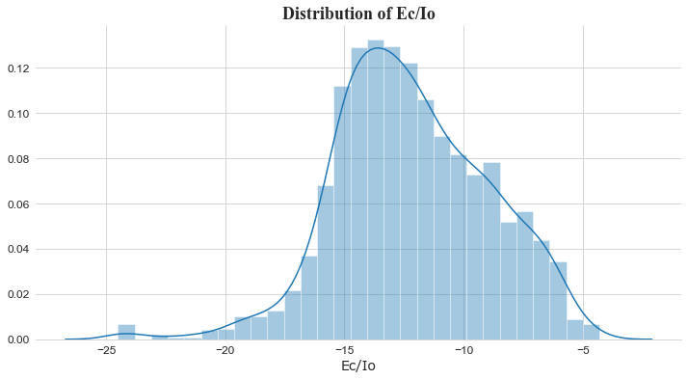

### 2.12 Rx Power

Map Plot

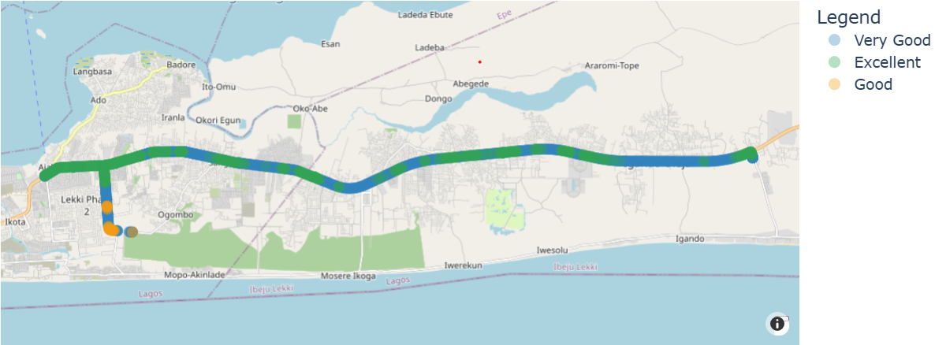

That table and the counts

|  |  |  |  |
| --- | --- | --- | --- |
| **Colors** | **Range of Values** | **Categories** | **Count** |
|  | -50 to 0 | Excellent | 799 |
|  | -51 to -70 | Very Good | 1300 |
|  | -71 to -85 | Good | 30 |
|  | -85 to -100 | Fair | 0 |
|  | -100 and above | Poor | 0 |

Count plot

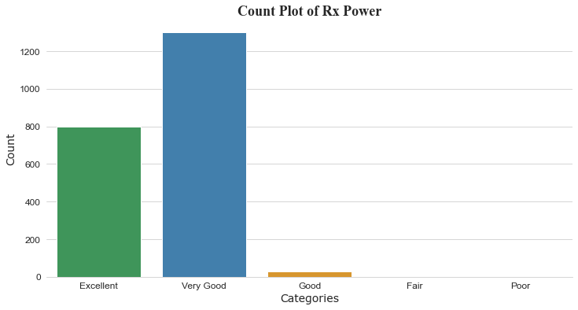

Distribution plot

1. Mean: -53.37
2. Standard Deviation: 8.251

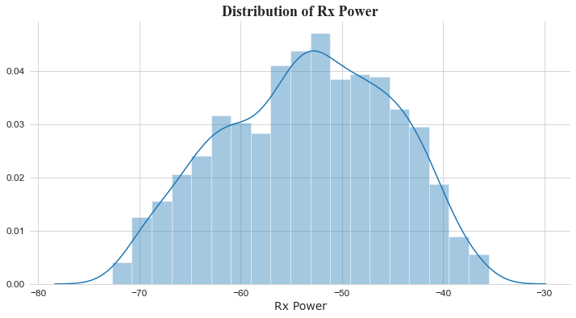

### 2.13 RSCP

Map Plot

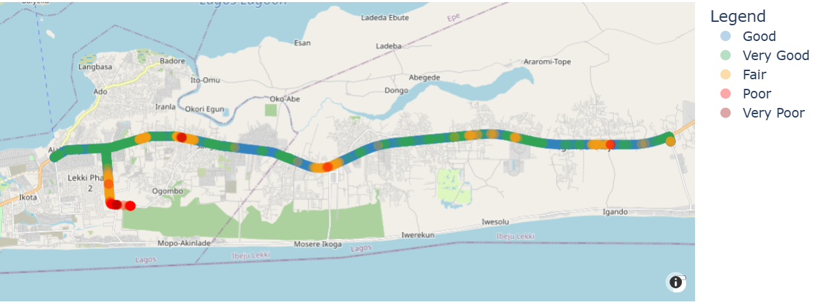

That table and the counts

|  |  |  |  |
| --- | --- | --- | --- |
| **Colors** | **Range of Values** | **Categories** | **Count** |
|  | -60 to 0 | Very Good | 628 |
|  | -61 to -75 | Good | 1176 |
|  | -76 to -85 | Fair | 280 |
|  | -86 to -95 | Poor | 39 |
|  | -96 to -124 | Very Poor | 3 |

Count plot

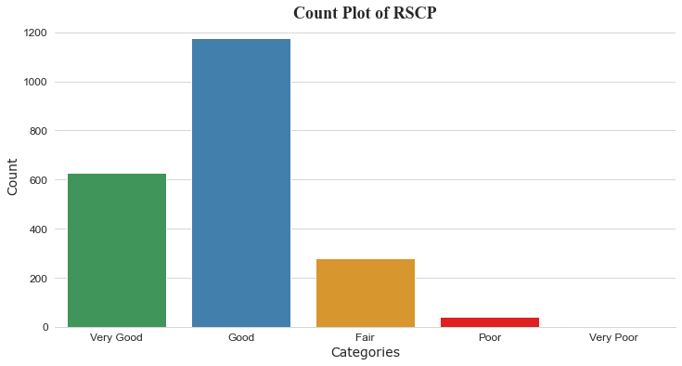

Distribution plot

1. Mean: -65.996
2. Standard Deviation: 8.893

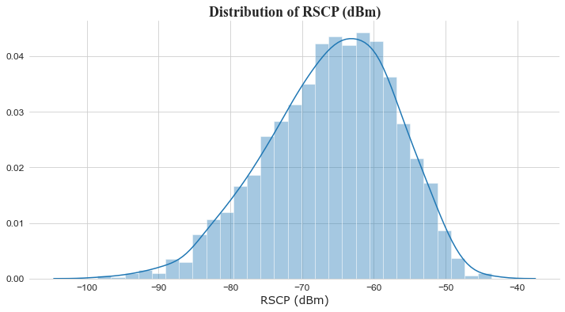

## Airtel

The Airtel network exhibits a generally good performance, with 100% success rates for CSSR, CSR, and HOSR, indicating reliable service with minimal dropped calls. A DCR of 9.09% suggests some call drops occurred. Call establishment was generally successful, with only 3 out of 36 attempted calls blocked. Ecio values indicate excellent signal quality for voice calls with an average of -8.534 and a moderate standard deviation. Rx Power demonstrates exceptional performance with a significant majority of measurements categorized as "Excellent" and an average of -56.982, indicating strong signal reception. RSCP values, while generally good, show some areas of concern. The average RSCP of -65.848 with a standard deviation of 10.049 suggests potential signal strength variations. A significant portion of measurements fell into the "Fair," "Poor," and "Very Poor" categories, indicating potential challenges in signal reception and potentially impacting data speeds and overall user experience in certain areas. In summary, while the MTN network exhibits strong call quality and good signal strength in some aspects, the lower RSCP values and the observed DCR indicate potential areas for improvement in overall signal strength and call reliability.

|  |  |  |
| --- | --- | --- |
| **S/N** | **Parameters** | **Count** |
| 1 | Call Setup | 33 |
| 2 | Call initiation | 36 |
| 3 | Call Established | 33 |
| 4 | Call Dropped | NIL |
| 5 | Call Blocked | 3 |
| 6 | Handover | NIL |
| 7 | Handover Failure | NIL |
| 8 | SHO Procedure Complete | 991 |
| 9 | RRC Call Establishment | 34 |
| 10 | Call Attempt | 33 |

KPIS

|  |  |  |
| --- | --- | --- |
| **s/N** | **Key Parameter Indicators** | **Percentage** |
| 1 | CSSR | 100 |
| 2 | DCR | 9.09 |
| 3 | CSR | 100 |
| 4 | HOSR | 100 |

### 2.2.1 Ec/Io

Map Plot

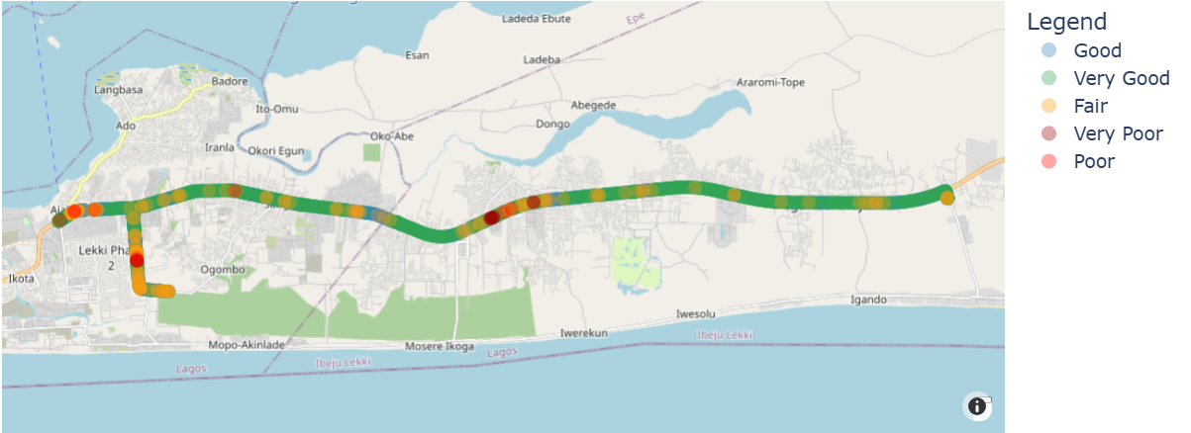

That table and the counts

|  |  |  |  |
| --- | --- | --- | --- |
| **Colors** | **Range of Values** | **Categories** | **Count** |
|  | 0 to -8 | Very Good | 1093 |
|  | -9 to -12 | Good | 881 |
|  | -13 to -16 | Fair | 155 |
|  | -17 to -20 | Poor | 8 |
|  | -21 and above | Very Poor | 12 |

Count plot

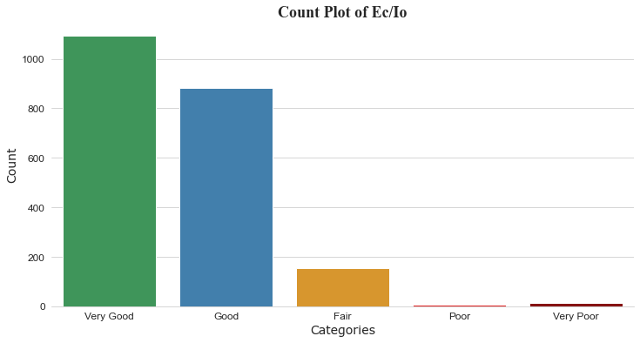

Distribution plot

1. Mean: -8.534
2. Standard Deviation: 3.097

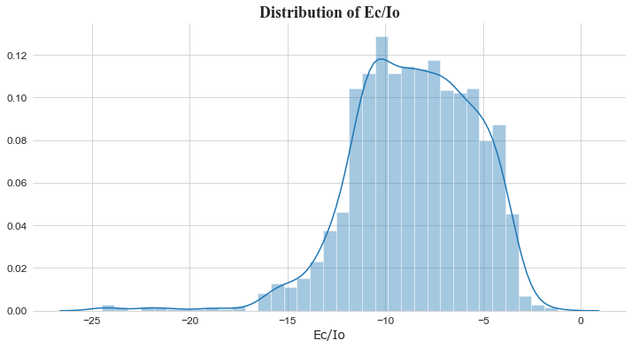

### 2.2.2 Rx Power

Map Plot

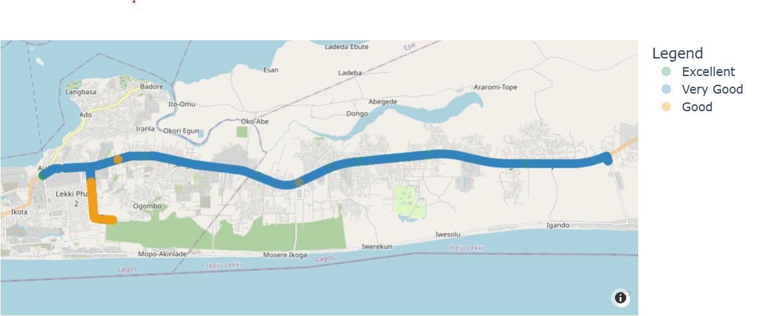

That table and the counts

|  |  |  |  |
| --- | --- | --- | --- |
| **Colors** | **Range of Values** | **Categories** | **Count** |
|  | -50 to 0 | Excellent | 1518 |
|  | -51 to -70 | Very Good | 451 |
|  | -71 to -85 | Good | 188 |
|  | -85 to -100 | Fair | 0 |
|  | -100 and above | Poor | 0 |

Count plot

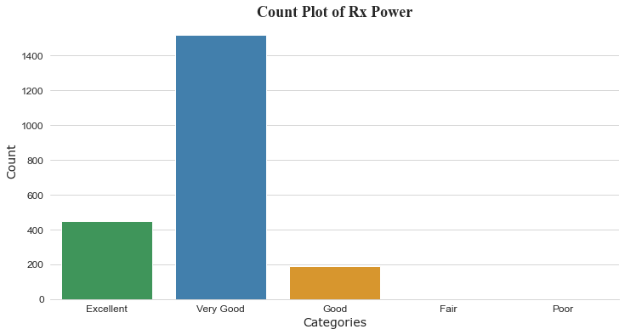

Distribution plot

1. Mean: -56.982
2. Standard Deviation: 8.462

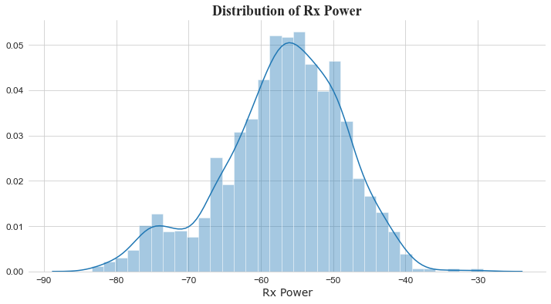

### 2.2.3 RSCP

Map Plot

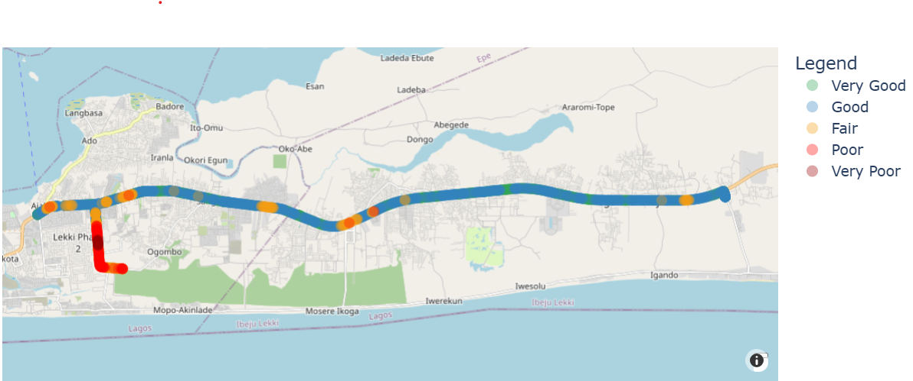

That table and the counts

|  |  |  |  |
| --- | --- | --- | --- |
| **Colors** | **Range of Values** | **Categories** | **Count** |
|  | -60 to 0 | Very Good | 716 |
|  | -61 to -75 | Good | 1076 |
|  | -76 to -85 | Fair | 246 |
|  | -86 to -95 | Poor | 97 |
|  | -96 to -124 | Very Poor | 14 |

Count plot

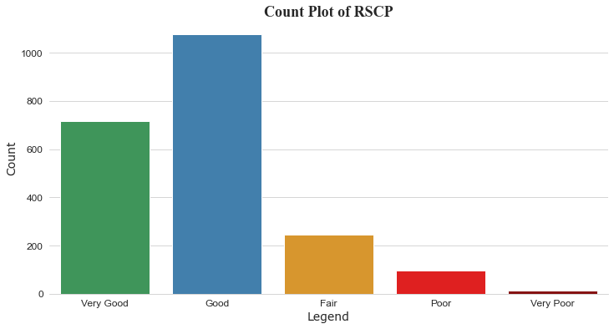

Distribution plot

1. Mean: -65.848
2. Standard Deviation: 10.049

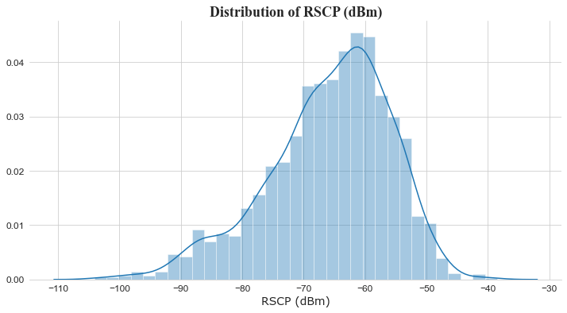

## Glo

The GLO network exhibits areas of concern. While CSSR and HOSR indicate reliable service, a high DCR of 8.571% suggests significant call drops. CSR of 94.285% is also low, indicating potential issues with call setup or maintenance. Call establishment was generally successful, with only 1 out of 37 attempted calls dropped and no blocked calls. Ecio values indicate good signal quality for voice calls with an average of -10.804 and a moderate standard deviation. Rx Power demonstrates excellent performance with a significant majority of measurements categorized as "Excellent" or "Very Good" and an average of -55.363, indicating strong signal reception. RSCP values, while generally good, show some areas of concern. The average RSCP of -66.816 with a standard deviation of 8.043 suggests potential signal strength variations. A significant portion of measurements fell into the "Fair," "Poor," and "Very Poor" categories, indicating potential challenges in signal reception and potentially impacting data speeds and overall user experience in certain areas. In summary, while Rx Power suggests good signal strength, the high DCR, low CSR, and lower RSCP values indicate potential areas for improvement in overall call quality and reliability.

|  |  |  |
| --- | --- | --- |
| **S/N** | **Parameters** | **Count** |
| 1 | Call Setup | 33 |
| 2 | Call initiation | 37 |
| 3 | Call Established | 33 |
| 4 | Call Dropped | 1 |
| 5 | Call Blocked | NIL |
| 6 | Handover | 34 |
| 7 | Handover Failure | Nil |
| 8 | SHO Success Rate | Nil |
| 9 | RRC Established | 38 |
| 10 | Call Attempt | 35 |

KPIS

|  |  |  |
| --- | --- | --- |
| **s/N** | **Key Parameter Indicators** | **Percentage** |
| 1 | CSSR | 94.285 |
| 2 | CSR | 94.285 |
| 3 | DCR | 8.571 |
| 4 | HOSR | 100 |

### 2.3.1 Ec/ Io

Map Plot

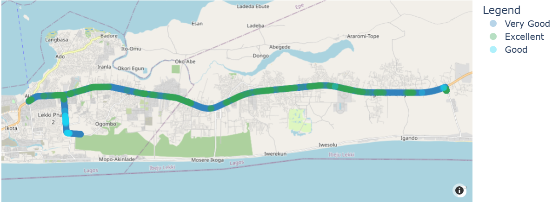

That table and the counts

|  |  |  |  |
| --- | --- | --- | --- |
| **Colors** | **Range of Values** | **Categories** | **Count** |
|  | 0 to -8 | Very Good | 541 |
|  | -9 to -12 | Good | 972 |
|  | -13 to -16 | Fair | 611 |
|  | -17 to -20 | Poor | 48 |
|  | -21 and above | Very Poor | 6 |

Count plot

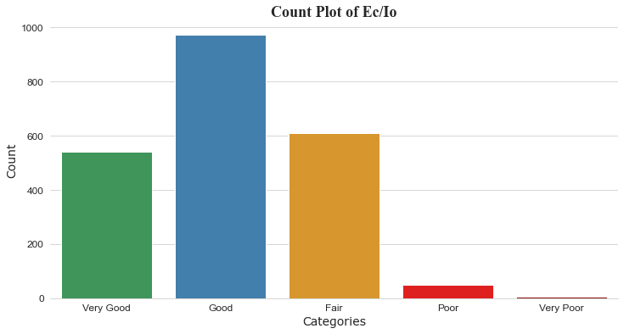

Distribution plot

1. Mean: -10.804
2. Standard Deviation: 3.109

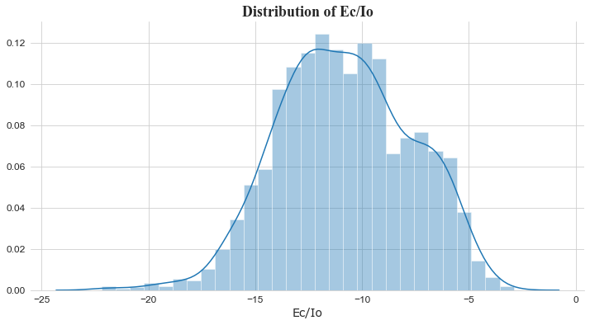

### 2.3.2 Rx Power

Map Plot

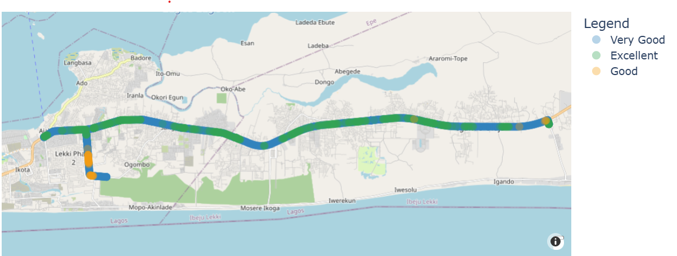

That table and the counts

|  |  |  |  |
| --- | --- | --- | --- |
| Colors | Range of Values | Categories | Count |
|  | -50 to 0 | Excellent | 498 |
|  | -51 to -70 | Very Good | 1633 |
|  | -71 to -85 | Good | 47 |
|  | -85 to -100 | Fair | 0 |
|  | -100 and above | Poor | 0 |

Count plot

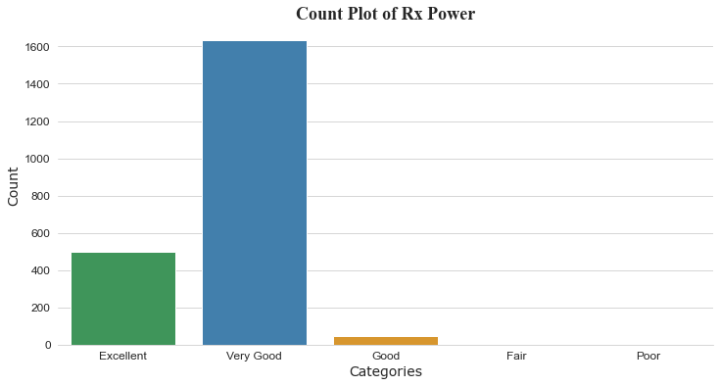

Distribution plot

1. Mean: -55.363
2. Standard Deviation: 6.783

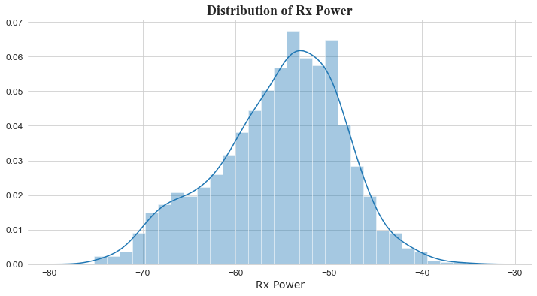

### 2.3.3 RSCP

Map Plot

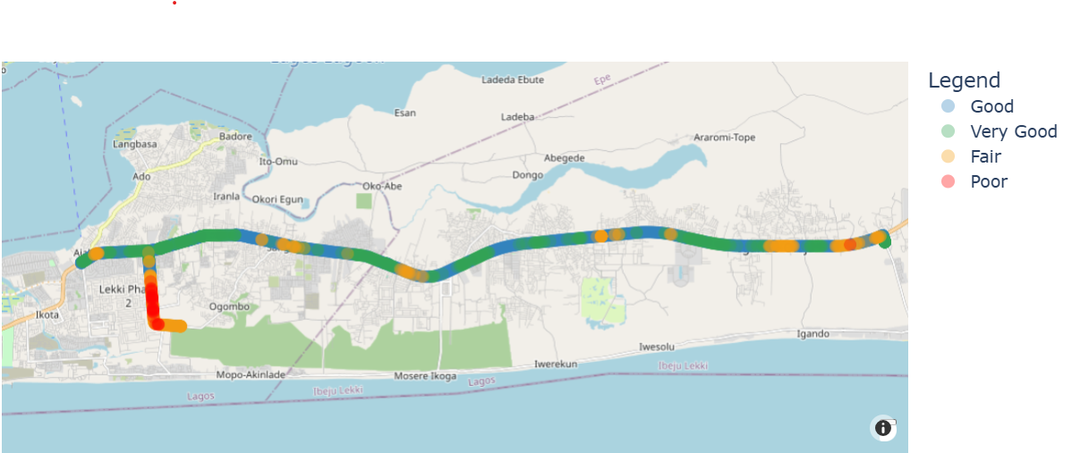

That table and the counts

|  |  |  |  |
| --- | --- | --- | --- |
| **Colors** | **Range of Values** | **Categories** | **Count** |
|  | -60 to 0 | Very Good | 479 |
|  | -61 to -75 | Good | 1358 |
|  | -76 to -85 | Fair | 314 |
|  | -86 to -95 | Poor | 27 |
|  | -96 to -124 | Very Poor | 0 |

Count plot

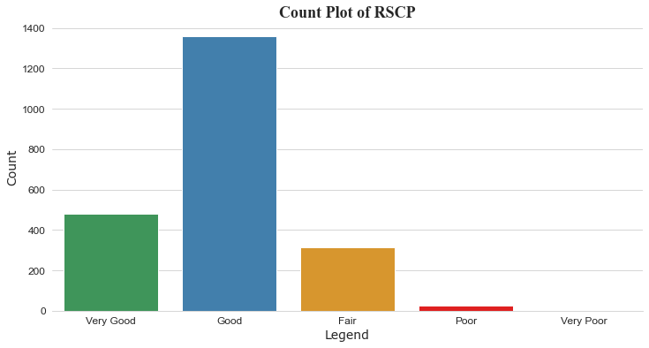

Distribution plot

1. Mean: -66.816
2. Standard Deviation: 8.043

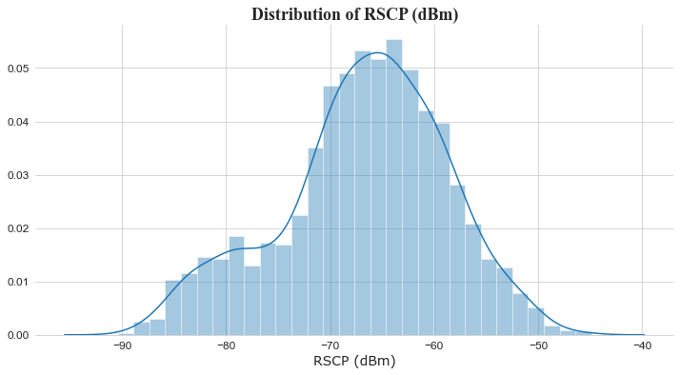

## 9Mobile

The 9Mobile network exhibits significant performance issues. CSSR and CSR values of 82.354% and 82.352%, respectively, indicate suboptimal call setup success rates. A very high DCR of 64.705% suggests a high rate of dropped calls, significantly impacting user experience. Call establishment was also challenging, with 11 out of 25 attempted calls blocked. Ecio values indicate moderate signal quality for voice calls with an average of -12.827 and a high standard deviation. Rx Power demonstrates a concerning trend with a significant number of measurements falling into the "Fair" and "Poor" categories and an average of -70.90 with a high standard deviation of 18.01, indicating weak signal reception. RSCP values are particularly concerning, with a significant number of measurements falling into the "Poor" and "Very Poor" categories, an average of -83.834, and a high standard deviation of 20.066. This suggests severe signal strength issues in the tested area, likely impacting all aspects of network performance. In summary, the 9Mobile network exhibits significant performance issues with high call drop rates, low call setup success, and weak signal strength across all key parameters. These findings indicate a poor network performance and a subpar user experience.

|  |  |  |
| --- | --- | --- |
| **S/N** | **Parameters** | **Count** |
| 1 | Call Setup | 14 |
| 2 | Call initiation | 25 |
| 3 | Call Established | 14 |
| 4 | Call Dropped | 1 |
| 5 | Call Blocked | 11 |
| 6 | Handover | NIL |
| 7 | Handover Failure | NIL |
| 8 | SHO Success Rate | NIL |
| 9 | RRC Established | 22 |
| 10 | Call Attempt | 17 |

KPIS

|  |  |  |
| --- | --- | --- |
| **s/N** | **Key Parameter Indicators** | **Percentage** |
| 1 | CSSR | 82.354 |
| 2 | CSR | 82.352 |
| 3 | DCR | 64.705 |
| 4 | HOSR | 100 |

### 2.4.1 Ec/Io

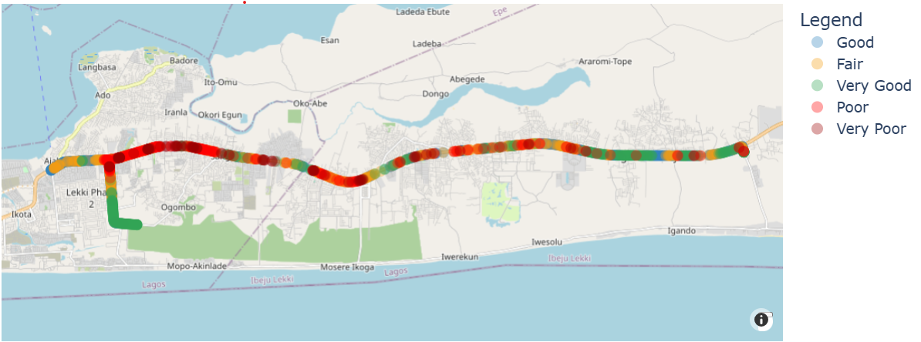

Map Plot

That table and the counts

|  |  |  |  |
| --- | --- | --- | --- |
| **Colors** | **Range of Values** | **Categories** | **Count** |
|  | 0 to -8 | Very Good | 349 |
|  | -9 to -12 | Good | 533 |
|  | -13 to -16 | Fair | 545 |
|  | -17 to -20 | Poor | 279 |
|  | -21 and above | Very Poor | 94 |

Count plot

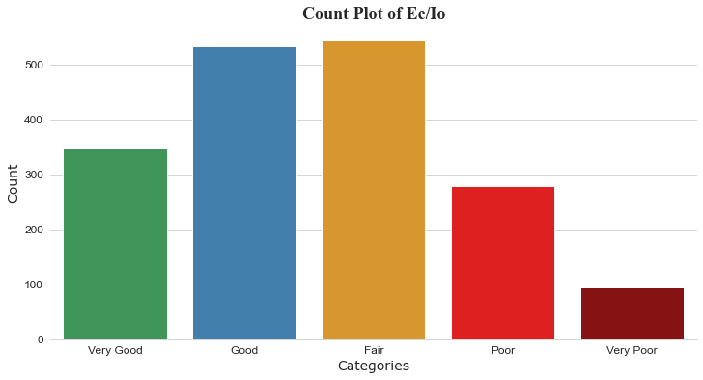

Distribution plot

1. Mean: -12.827
2. Standard Deviation: 4.529

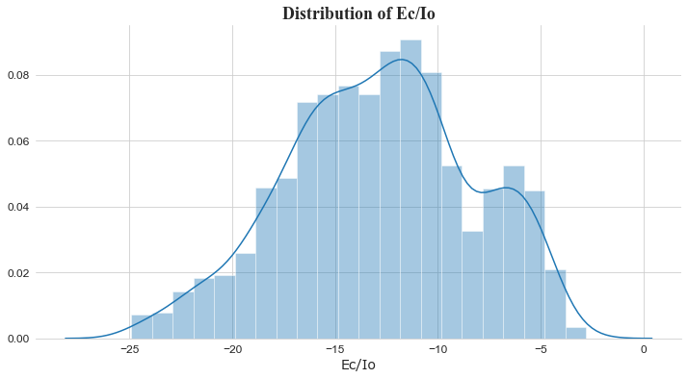

### 2.4.2 Rx Power

Map Plot

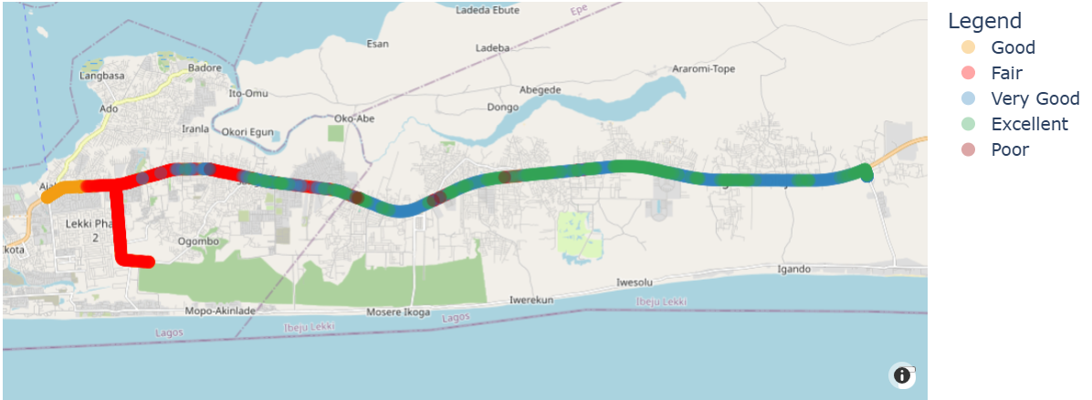

That table and the counts

|  |  |  |  |
| --- | --- | --- | --- |
| **Colors** | **Range of Values** | **Categories** | **Count** |
|  | -50 to 0 | Excellent | 328 |
|  | -51 to -70 | Very Good | 668 |
|  | -71 to -85 | Good | 282 |
|  | -85 to -100 | Fair | 724 |
|  | -100 and above | Poor | 6 |

Count plot

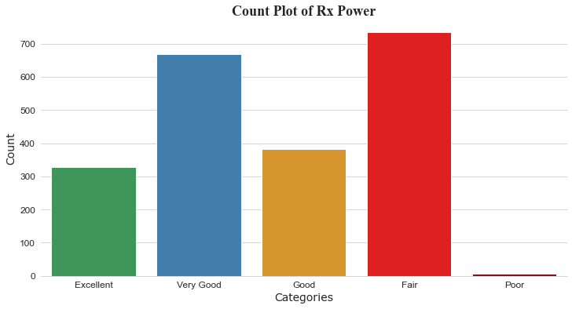

Distribution plot

1. Mean: -70.90
2. Standard Deviation: 18.01

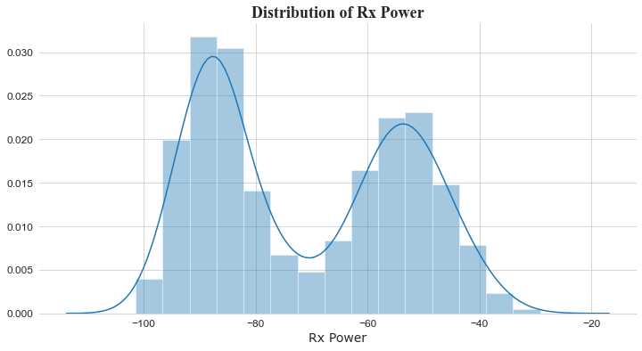

### 2.4.3 RSCP

Map Plot

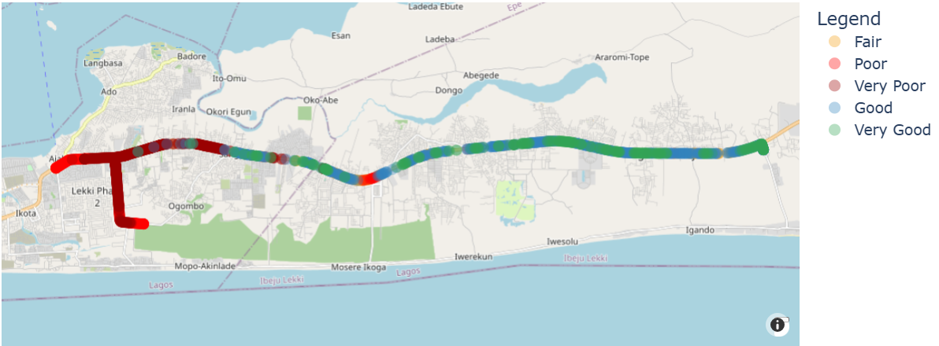

That table and the counts

|  |  |  |  |
| --- | --- | --- | --- |
| **Colors** | **Range of Values** | **Categories** | **Count** |
|  | -60 to 0 | Very Good | 262 |
|  | -61 to -75 | Good | 514 |
|  | -76 to -85 | Fair | 104 |
|  | -86 to -95 | Poor | 237 |
|  | -96 to -124 | Very Poor | 683 |

Count plot

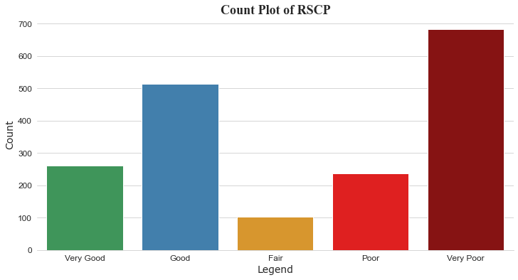

Distribution plot

1. Mean: -83.834
2. Standard Deviation: 20.066

